Work and Energy experiment (1/2/21) Name_________________________
Period ________________________

Go to: https://phet.colorado.edu/en/simulation/energy-skate-park

Equations of interest-

Potential energy (gravitational) = mass*acceleration of gravity*height or PE = mgh
Kinetic energy = ½ mass * velocity squared or KE = ½mv²

Energy Skate Park
- Click on Potential Energy Reference on the right hand side.
- Drag the bottom of the track all the way down to ground level, and start the skater at the top very top of the track. Move left hand side of track to some height between 8 & 10m.
- Click Show Grid
- Click Show Pie Chart
- What does the pie chart represent, and how does it change? ________________________ ________________________________________________________________________

- Move skateboarder to top of track. Click on the Energy vs. Position Button.
- Click play button. Sketch the energy vs. position graph for the skateboarder as he moves from the top left to the top right. Label K, U, and Total Energy

- Calculate the potential energy of the skater at his maximum height (if you click choose skater at the top right it will tell you the mass of the skater).

- Using the answer from number 8, calculate the speed of the skater at the bottom of the ramp.

- Calculate the speed of the skater when he is 1 m from the bottom of the ramp.

- What do you think will happen to the skater when you add friction? _________________ ________________________________________________________________________
- Add friction. Describe the pie chart, and explain what happens to the skater: __________ ________________________________________________________________________
________________________________________________________________________

- Were you right in number 11?

An examination of the effect of potential energy on speed

- Hit the “reset” button. Pause the simulation. Click on “grid”. Reconfigure the ramp so that it looks like the figure below. Make sure bottom 4 meters or more is horizontal. Move skateboarder to 2 meters height (above zero meters).

Please note that there is a tape measure which is included to show you the measurement interval (distance) of 4 meters. This is the interval you will time the skateboarder traveling.

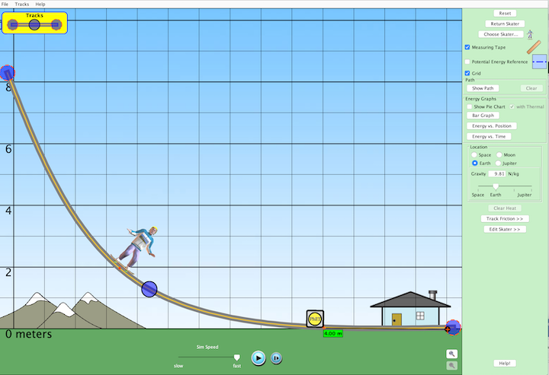

- Change “sim speed” to slow. Get a stopwatch and reset to zero. Hit the start button on the simulation. Use your stopwatch to time the time it takes for the skate boarder to travel the last 4 (horizontal) meters of the ramp. Distance = 4m.

2 meters start data.
Perform 5 trials and record below. Calculate the average time and then calculate the velocity of the skate boarder by using distance/time = velocity.

Table 1
2 meter starting height

Trial | Time  (s) | Calculated  Velocity  (m/s)
1

2

3

4

5

Average

- Repeat step 15 for start heights of 4 meters and 8 meters. Show all work below.

Table 2
4 meter starting height

Trial | Time  (s) | Calculated  Velocity  (m/s)
1

2

3

4

5

Average

Table 3
8 meter starting height

Trial | Time  (s) | Calculated  Velocity  (m/s)
1

2

3

4

5

Average

- Fill out table 1 below

Table 1
An examination for the effect of potential energy on speed

Height  (m) | Time  (s) | Calculated velocity  (m/s) | Height ratio  using 2m as reference  (height divided by 2m) | Velocity ratio  using 2m velocity as reference velocity  (height/2m)
0 | 0 | 0 | 0 = 0m/2m | 0
2 |  |  | 1 = 2m/2m | 1
4

8

Plot height vs. velocity

- Based upon the data (& plot) above, what can you say about potential energy (i.e., as a height) and velocity? Is the relationship linear?

An examination of stopping distance vs. speed.

In this part of the lab we will examine the effect of speed on stopping distance

- Reconfigure the ramp so that it looks like the figure below. Please note that the level part of the track should be at least 8 meters in length in order for skateboarder to have enough room to stop when friction is turned on.

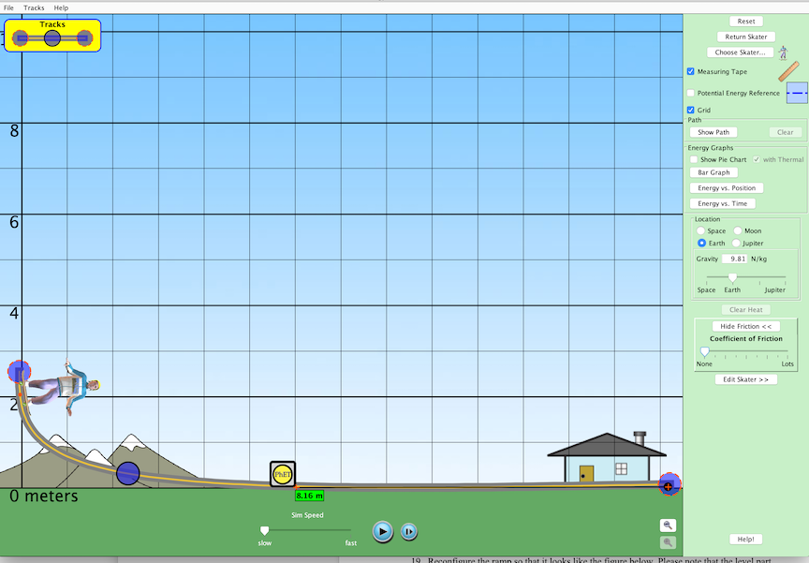

- Please note that friction is turned off until the skateboarder reaches the flat part of track.
In the figure above the flat part of track is where the RHS of tape measure is located. Make sure ‘sim speed” is on slow.

Once you click on start, let the skateboarder slide down the incline until he is near the flat part of track. Hit pause and use the ‘step button” until dot on skateboard is at the flat part of track (i.e., RHS of tape measure). Next, turn friction to highest setting. Click ‘play button” to resume. Measure the distance that it takes for the skateboarder to stop.

Distance to stop (at 2m height) = __________m

- Move skateboarder to a 1 meter starting distance. Repeat same procedure as above.

Distance to stop (at 1m height) = __________m

- Based upon your observations in steps 20 & 21 above, how far would the skateboarder travel if the starting height was 8 meters? What can you say about the relationship between stopping distance and velocity? Is it a linear relationship?

